Employee Database.

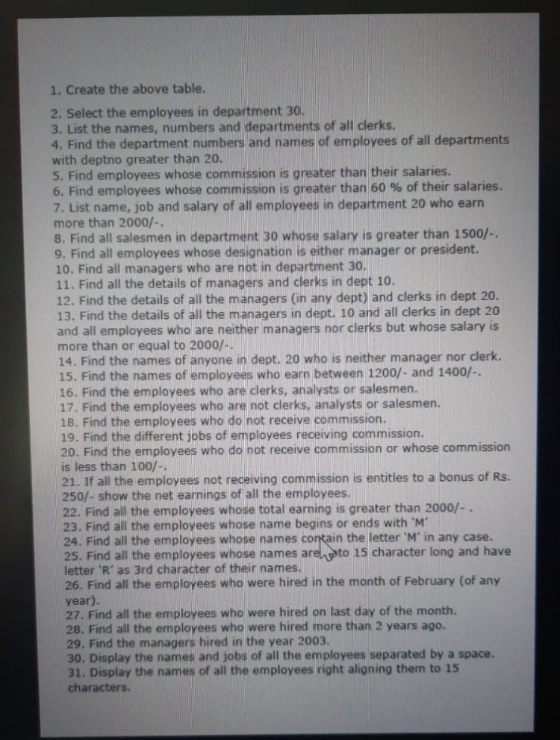

1.Create the employee table.

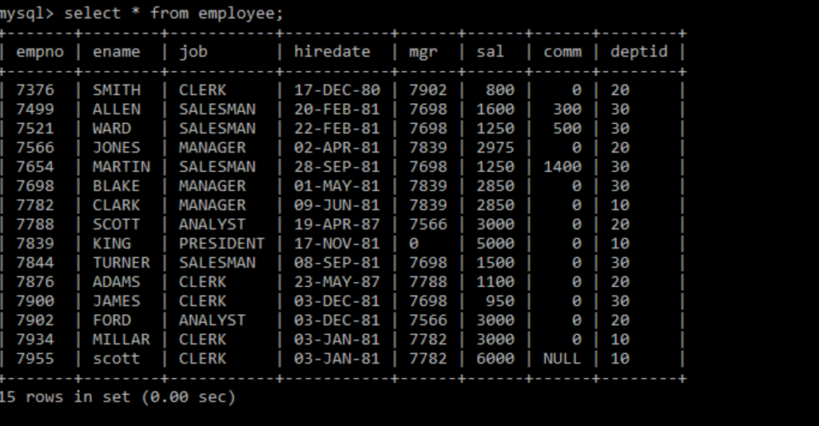

2. select the employees in department 30.

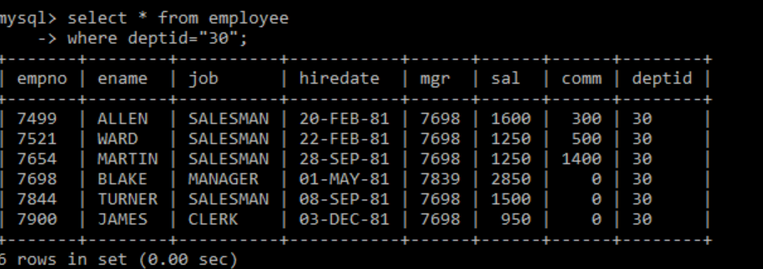

3. list the names, number and departments of all clerks.

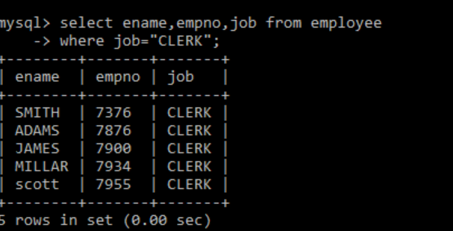

4. Find the department numbers and names of employees of all departments with deptid greater than 20.

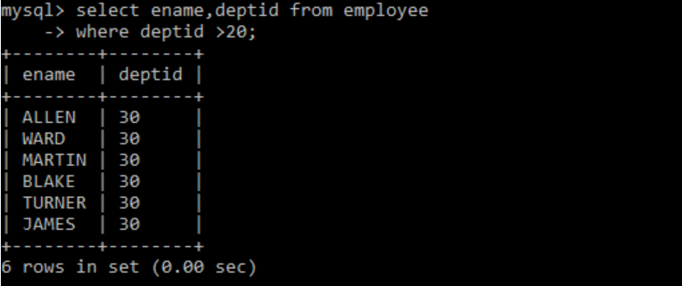

5.Find employees whose commission Is greater than their salaries.



6.Find employees whose commission is greater than 60% of their salaries.

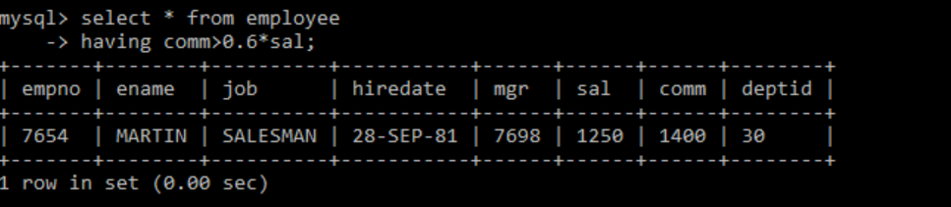

7. List name, job and salary of all employees in department 20 who earn more than 2000/-.



8. Find all salesman in department 30 whose salary is greater than 1500/-.

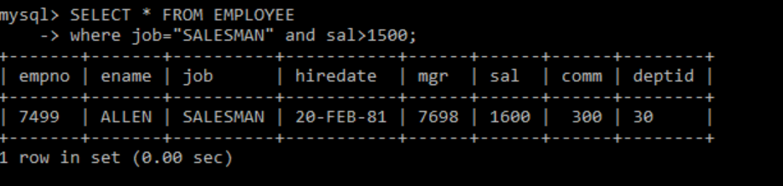

9. Find all employees whose designation is either manager or president.

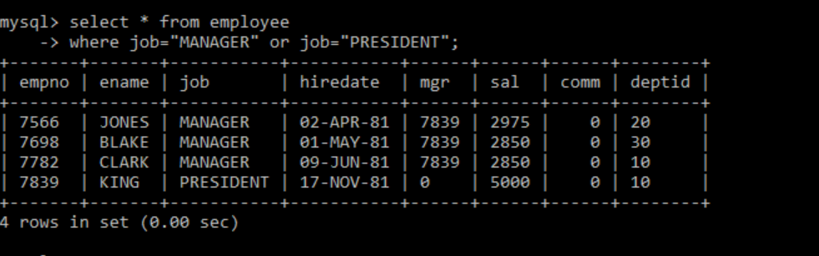

10.



11.

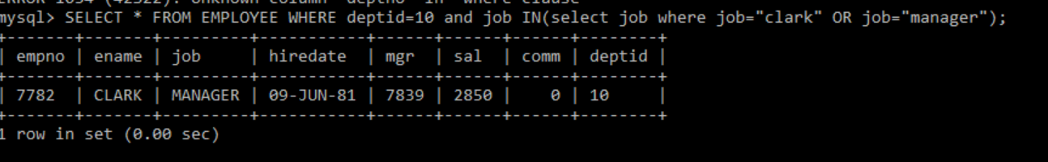

12.

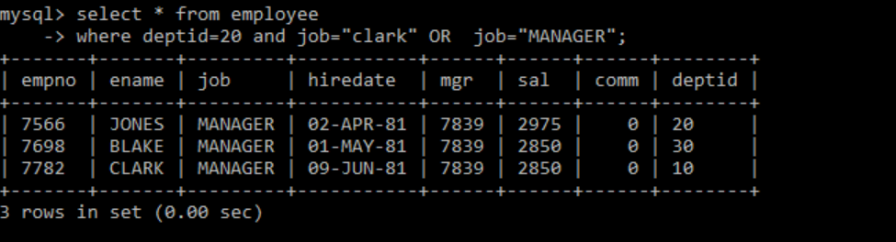

13. Find the details of the all the management in dept.10 and all clerks in dept20 and all employees who are neither managers nor clearks but whose salary is more than or equal to 2000\-.

14.

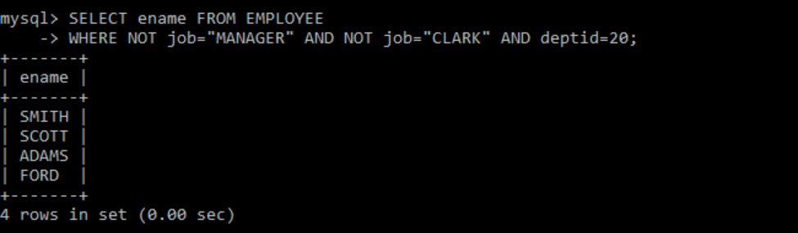

15.



16.

17.

18.

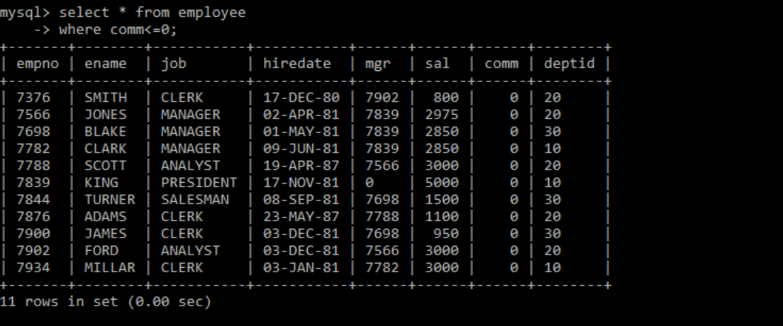

19.

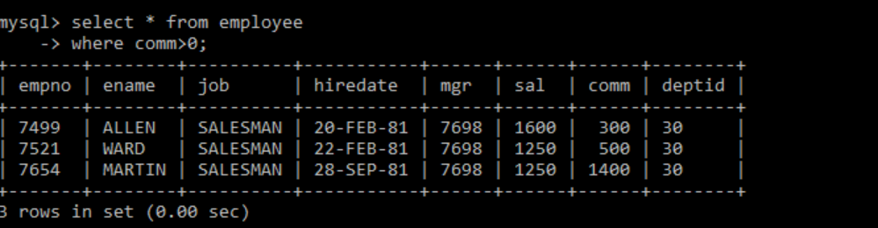

20.

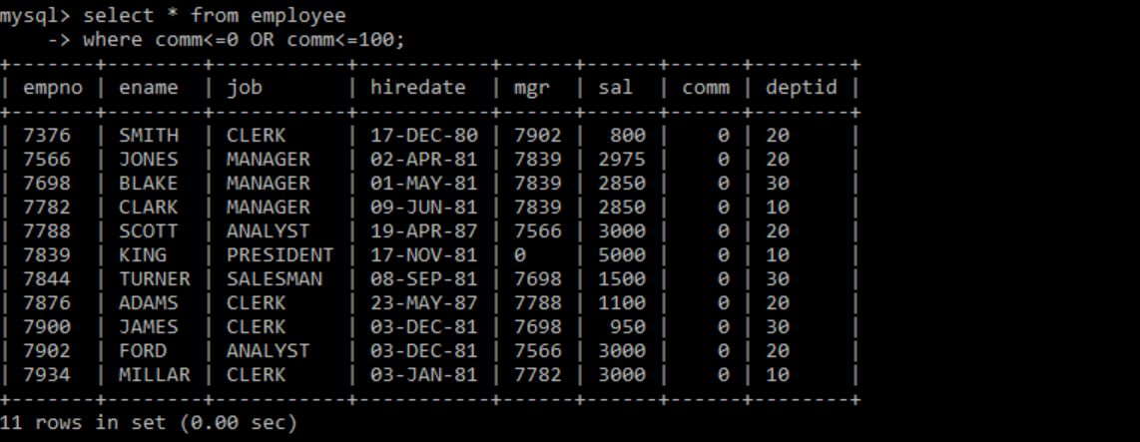

21.

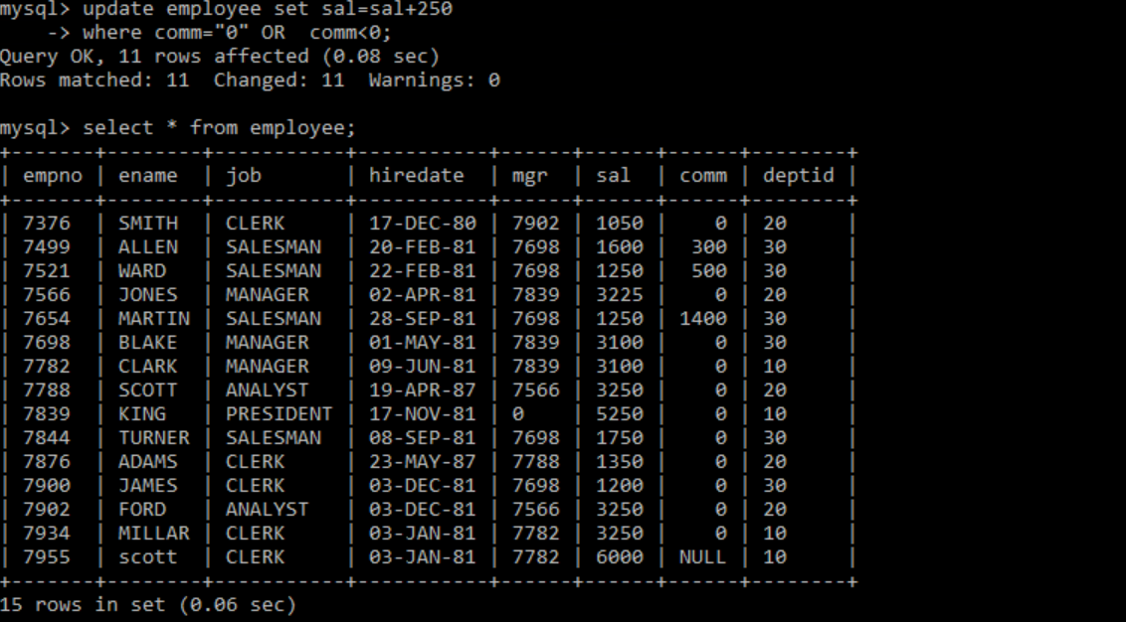

22.

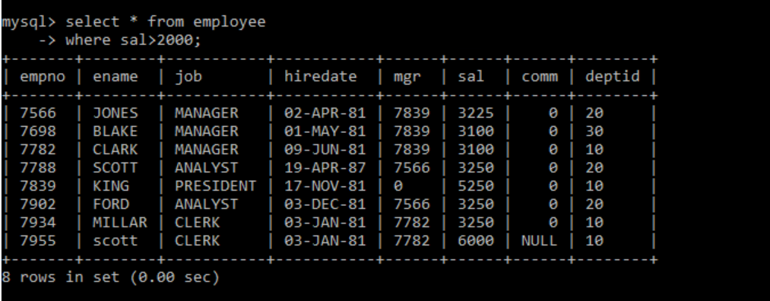

23.

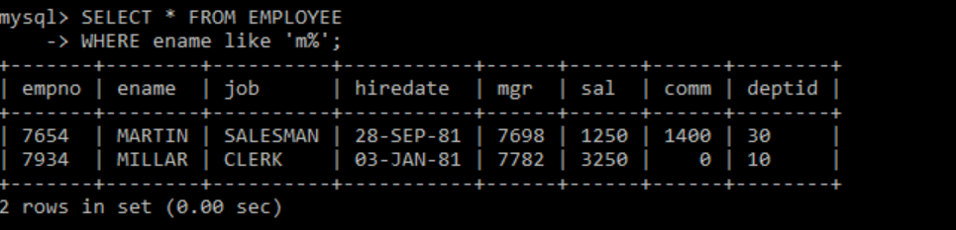

24.

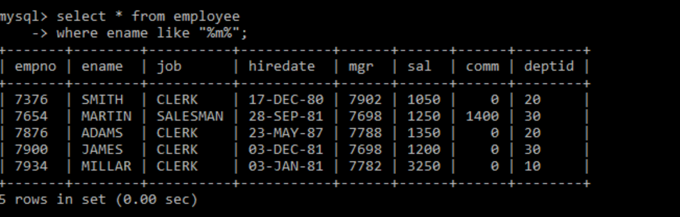

25.